Waterpark holiday by the beach
At this family-friendly club hotel, close to the beach, there is something for everyone, from the pool landscape to the many exciting waterslides at the hotel's aqua park. All-day colorful program of activities and entertainment for all ages and several restaurants will delight all guests.
GRIFID Club Hotel Bolero is the second property of the Bulgarian hotel chain GRIFID HOTELS. Guided by the GRIFID's high standards of quality and unsurpassed service, a team of experienced professionals fulfills the company’s ongoing commitment to guest satisfaction.

Highlights and new services
- NEW: The new main restaurant has a modern design and is complemented by the hotel's "Aqua Fun" concept with its impressive aquarium wall.
Take a break watching the fish in the aquarium and reconnect with nature. Dining with a view of the aquatic world is a wonderful experience, especially for children and fish lovers.
- GRIFID Aqua Park offers visitors a thrilling adventure experience and lot of family fun in the sun
- NEW: A la carte breakfast on the cosy terrace of the Food Court for a premium feel.
- Stay 4 nights or more to enjoy the DINE Around programme free of charge.
Delicious moments for food lovers with GRIFID DINE Around program: molecular cuisine (1* stay), fish and Rodizio, Italian, Bulgarian, Asian and European cuisine in hotel Vistamar and Metropol (16+) and Bolero
Advance reservation is required.
- NEW: The new Food Court with 3 new a la carte restaurants, Fish Restaurant, Asian Restaurant and Italian Restaurant, each with its own view and dedicated to a different cuisine design, welcomes you on a culinary journey.
- Gala dinner! On these evenings, you'll see the restaurant transformed with an explosion of decorations, signature menus and specialty cocktails. There's music to keep you entertained and a heightened sense of celebration throughout the hotel. (every 10 days)
- Pop up parties in high season: Beach parties and BBQ evenings ( once in 10 days) and NEW: Foam parties in GRIFID Vistamar
- Sunbeds and umbrellas on the beach (upon availability); Beach bar
- Holiday with teenagers: Teen zone for 12-17 year olds with entertainment, Playstation, arcade games and Soda bar.
- NEW: Enriching in-room amenities with tea/coffee making facilities in all room types
- Certificated by Travelife
- Program for guests with allergies: special menus for the most common food allergies (on request and after prior notification at the time of booking).
Special for the kids
- NEW: Kids Buffet with designed kids’ area
- NEW: Baby and kids’ menu in a la carte Restaurants
- NEW: Baby buffet (milk, purees, cereals, baby milk)
- NEW: Sustainable activities in the children's own garden
- The GRIFID Mini Club shaped like a Pirate Ship
- Aqua Mini disco in the Kids‘ Aqua park (weather dependent)
- The Kids Club for ages 4 - 12 years old offers games and theme activities with professional animator every day
- Kids yoga program
- Kids evenings parties (incl. Theme parties in Mini Club) - against charge

General information

- Diverse Ultra All Inclusive product
- 3 separated buildings
- The outdoor area is terraced with some stair areas
- 8-storey main building
- 50 m from the beach
- 15 km from Varna
- 30 km from Varna Airport
- 500 m from the center of the resort
- 500 m from the shopping center
- 400 m from a public bus station
- Languages spoken: Bulgarian, English, German, French, Russian
- 24-hours reception & 24 hours security
- Guest Relation services - taking care of all little details that matter for your stay
- Main restaurant, 4 a-la-carte restaurants (Asian, Bulgarian, Italian, Fish restaurants)
- GRIFID Dine Around program
- Coffee shop
- Pool bar and Bar salon offer variety of local and international alcoholic and non-alcoholic beverages, on the Beach bar - only local ones;
- Snack terrace offer great variety of tasty snacks:
- Parking - outdoor parking lots and indoor garage - limited and against charge
- GRIFID Souvenir Shop
- Free Wi-Fi connection in whole hotel area and in the rooms
- Taxi & Rent-a-car services
- Laundry and ironing service - at a charge
- Currency exchange
- Doctor
- Gym, Wellness & Relax center
- Entertainment, sport activities and animation program for adults & children
- Cooking classes
- Certificated by Travelife

ACCOMMODATION
- Check-in time - from 15:00h - starts with afternoon snack menu
- Check-out time - until 11:00h - ends with late continental breakfast
- 304 hotel premises – double rooms and family rooms
- Hairdryer
- Cosmetic mirror in bathrooms
- International dialing phone
- Central air conditioning system
- Satellite TV
- Free Wi-Fi connection
- In-room safe (free of charge)
- Mini bar - free of charge, daily restocked (water, soft drinks, beer)
- Tea/coffee making facilities
- Balcony
- Pillow menu
- Top mattress menu - upon request
- Baby cots - free of charge
Early check-in and late check-out depend on the availability of the hotel and are subject to additional payment.

Restaurants
Part of ULTRA All Inclusive basis

BOLERO MAIN RESTAURANT
Restaurant with a modern design and impressive aquarium walls, serving breakfast, lunch and dinner in a buffet style.
Breakfast 07:30 - 10:00 buffet
Lunch 12:30 - 14:00 buffet
Dinner 18:00 - 21:30 buffet
- Capacity: 350 seats
- Buffet breakfast, lunch and dinner
- Varied culinary delights offered via show cooking, carving, pizza and pasta corner; diet, salad and delicious pastry buffets and traditional local buffet
- Beverage buffet with mineral water, soft drinks, draft beer and country wine, coffee and tea;
- Baby buffet (milk, purees, cereals, baby milk)
- Highchairs for children
- Culinary theme buffets
- Gala dinner once in 10 days;
Dress code for dinner: Smart Casual: shorts are permitted except swimming trunks, beach attire, flip flops and sleeveless shirts.
Smoking is not allowed

FOOD COURT
A la carte breakfast on the terrace of a la carte venue 08:00-10:00
Late breakfast on the Snack terrace 10:00 - 12:00 a la carte service
Lunch 12:00 – 14:00 – grill, pasta, pizza, dönners, burgers, side dishes, soups, pastry buffet
Snack 14:00 - 17:00 – sandwiches, pancakes, burgers, hot dogs, dönners, salads and fruit buffet
Kids’ buffet with seating corner 12:00 – 14:00
Beverage buffet with mineral water, soft drinks, coffee, tea, draft beer and country wine
Nonsmoking indoor area

BULGARIAN A-LA-CARTE RESTAURANT “OLD HOUSE”
Welcomes its guests in the atmosphere and spirit of typical Bulgarian house.
Dinner 18:30 - 21:30 table service
- Capacity: 60 seats
- A la carte service and traditional Bulgarian menu for dinner
- Beverages - mineral water, soft drinks, draft beer and country wine
- Children’s menu & highchairs
- Advance reservation required
- Smoking is not allowed
- Included with minimum stay required
Dress code for dinner: Smart Casual: shorts are permitted except swimming trunks, beach attire, flip flops and sleeveless shirts.

ASIAN A-LA-CARTE RESTAURANT “ASIA”
Culinary trip to the Far East in an elegant ambience and discreet service.
Dinner 18:30 - 21:30 table service
- Capacity: 60 seats
- selection of exotic culinary Asian specialties
- Beverages - mineral water, soft drinks, draft beer and country wine
- Indoor and outdoor section
- Children’s menu & highchairs
- Advance reservation required
- smoking is not allowed
- included with minimum stay required
Dress code for dinner: Smart Casual: shorts are permitted except swimming trunks, beach attire, flip flops and sleeveless shirts.

ITALIAN A-LA-CARTE RESTAURANT
Let’s discover the main Italian foods, a gastronomic journey through this boot-shaped peninsula, from north to south, to the sound of a fork to wet your appetite.
Dinner 18:30 - 21:30 table service
- Capacity: 60 seats
- Italian specialties
- Beverages - mineral water, soft drinks, draft beer and country wine
- Indoor and outdoor section
- Children’s menu & highchairs
- Advance reservation required
- smoking is not allowed
- included with minimum stay required
Dress code for dinner: Smart Casual: shorts are permitted except swimming trunks, beach attire, flip flops and sleeveless shirts.

FISH A-LA-CARTE RESTAURANT
Feast on a range of delicious fresh seafood dishes.
Dinner 18:30 - 21:30 table service
- Beverages - mineral water, soft drinks, draft beer and country wine
- Indoor and outdoor section
- Children’s menu & highchairs
- Advance reservation required
- smoking is not allowed
- included with minimum stay required
- Dress code for dinner: Smart Casual: shorts are permitted except swimming trunks, beach attire, flip flops and sleeveless shirts.

GRIFID DINE AROUND PROGRAM
Valid for stays of minimum 4 nights
Delicious moments for food lovers with GRIFID DINE Around program!
A diverse and complimentary choice of a-la-carte restaurants with variety of cuisine types for our guests: molecular cuisine (1* stay), Rodizio, Italian, European, Fish, Asian and a traditional Bulgarian a la carte restaurant in GRIFID Metropol (16+), Vistamar and Bolero.
Advance reservation is required.

BARS
Part of ULTRA All Inclusive basis

POOL BAR
Situated next to a water cascade, next to the main outdoor swimming pool - lagoon type
09:00 - 19:00
- Capacity: 40 seats
- Ultra All Inclusive offer features mineral water, international and local alcoholic beverages, non-alcoholic beverages and refreshing cocktails, coffee and tea, draft beer and country wine
- Bar service

BAR SALON
Spacious amphitheater salon, situated on 3 levels, with large stage for evening performances and a dancing floor. There is a belonging sunny outdoor terrace.
19:00 - 24:00
- Capacity: 400 indoor seats and 80 outdoor ones on the terrace
- Ultra All Inclusive offer features mineral water, international and local alcoholic drinks, non-alcoholic beverages and cocktails, coffee and tea, draft beer and country wine
- bar service
GRIFID COFFEE SHOP
Open air outlet, next to the pool sun terrace offer delicious homemade pastry, cakes and ice-cream.
10:00 - 12:00
14:30 - 17:00
Ultra All Inclusive offer features cakes, cookies, crème, tartlets, ice cream, mineral water, non-alcoholic beverages, coffee and tea.

BEACH BAR
Situated on GRIFID Beach just in front of GRIFID Vistamar Hotel.
10:00 - 17:00
09:00 - 18:00 in high season
- Ultra All Inclusive offer features mineral water, local alcoholic beverages, non-alcoholic beverages and refreshing cocktails, coffee and tea, draft beer and country wine
- Bar service.

SWIMMING POOLS

OUTDOOR POOLS
Laguna-styled pool for family fun and classic pool perfectly suited to sporting activities
08:00 - 18:00
- Laguna pool with integrated complimentary whirlpool;
- Classic pool with dimensions: W 12 m.; L 25 m.
- Sun terraces by the pools
- Complimentary sun lounges, parasols and towels
- Life guard service provided

INDOOR POOL
08:00 - 18:00
- Heated with dimensions W 13 m., L 30 m.
- Complimentary whirlpool
- Complimentary lounges and towels
- Life guard service provided

BOLERO AQUA PARK
Operating from June till September, weather permitted. There are requirements for the access to adults’ aqua park section – height of minimum 1.40 m.
With total area of 8000 sq. m. is available free of charge for all Aqua Club Hotel Bolero guests. With its two sections: for adults and for children, each one accommodating 3 slides, the GRIFID Aqua Park offers the fun of over 400 m. of thrilling riding experience.
The slides:
- The PIPEline™ - a classic thriller designed with over 168 m. of alternating tunnels and high-speed open flume sections
- The TOPSY-TURVY™ (Tornado Slide) - 3 open funnels oscillate the rider several times before dropping them back into the ride and onto the next funnel. A combination of over 158 m. of dark tunnels and high-speed open flume sections. A slide with no match in Europe
- The BulletBOWL™ - with a steep (over 12 m. drop), tunneled in-run (88 m. of tunnels) and compact tubing bowl it provides a truly unparalleled centrifugal experience

Children’s Aqua Park Zone has 3 slides specially designed and built for children and are the central joy point of the area. The slides end up in to 2 children’s pools - beautifully decorated with beloved cartoon characters.

Changing rooms and safe deposit box available free of charge.

BEACH SERVICES INCLUDED
- One parasol and two sun beds per room on the beach, upon availability (only full paying customers)
- Children, accommodated free of charge, don’t receive the above services!

SPORT & ANIMATION ACTIVITIES

WELL FIT ZONE
Professional animation team takes care of the pleasant stay and active holiday at GRIFID Club Hotel Bolero.
- Outdoor activities: Gymnastics, Aerobics, Adventure walk, Nordic walk, Back Fit, Tae-Bo, Yoga, Kids own garden
- Multipurpose playground for basketball and volleyball, tennis (floodlit court), football, Foot tennis; Table tennis.
- Aqua gym, Aqua Jogging, Water polo
- Gym
- Darts
- French bowls
- Bicycle tours
- Dancing lessons
Air riffle shooting and archery
Evening shows - daily
Pop up events: Beach parties, BBQ evenings and Foam party at GRIFID Vistamar (once in 10 days; July- August)
Disco
Animation program for teenagers (from 13 to 17 years old) with different sport activities
GRIFID MINI CLUB
Shaped like a Pirate Ship it is a sheer 200 sq. m. fun zone for the little guests comprising of 2 separate indoor sections, outdoor veranda and playground area with many children’s attractions. All this is surrounded by the lush greeneries of the natural park.
10:00 - 12:30
15:00 - 17:30
- For children aged from 4 to 12 years
- Mini disco - every day
- Children’s show once in 2 weeks
- Theme days and activities - free of charge
- Special kids’ theme parties - against charge and advance reservation
GRIFID TEEN ZONE & SODA BAR
Zone reserved only for teens, accompanied by GRIFID animators.
19:00 – 23:00
Play station games, Mini soccer, table games thematic parties
Non-alcoholic soda drinks and cocktails

WELLNESS & RELAX
Bolero Wellness and Relax center offers perfect combination of relaxing and revitalizing treatments and temptations, sophisticated atmosphere and professional staff.
09:00 - 18:00
All treatments, sauna, hammam, services in Beauty salon are additionally charged!
- Hammam with steam bath, two saunas, hydro massage bath, hot stone massage, mud applications
- Relax zone
- Boutique - massage oils, fragrances and other body products
- Hairdresser, manicure and pedicure
- Massage rooms; Facial and body treatments and range of spa treatments
- Body and face cosmetic

ROOMS
- Economy room - max 2 pax, 22 m2
- Double deluxe room - 2+0, 2+1, 2+2 (2+2 is possible, if both children are up to 7.99 years of age and share one sofa bed), 25m2. Most rooms with view to the pools and garden.
- Family rooms - 2+2, 3+1. 32 m2. Pool/garden view. Coffee and tea facilities free of charge
- Apartment - 2+2, 3+1. 35 m2. Pool/garden view. Coffee and tea facilities free of charge

extra PAID SERVICES
- Parking outdoor lots and indoor garage - limited parking places
- Spa treatments in Wellness center
- Services in Beauty salon
- Wine selection in all restaurants
- Baby sitter services (for children at least 4 years old)
- Baby buggies & baby phone (on request)
- Billiards
- Tennis lessons for children and adults, illumination of the tennis court
- Bicycle (when not part of the animation bicycle tour)
- Transfer from and to Varna airport

MICE
- GRIFID Hotel Bolero provides 4 modern meeting rooms:
- Conference room “Bulgaria” - capacity 120 pax
- Conference room “Sofia” - capacity 40 pax
- Conference room “Varna” - capacity 16 pax
- Bar Salon GRIFID Hotel Bolero - capacity 400 pax
- Coffee breaks, audio-visual equipment, flipcharts – price included; services like welcome cocktails and official dinners - at extra charge

MISCELLANEOUS
- Pets are not allowed
- Hotel reserves the right to change opening hours of the outlets, if necessary
- Under Bulgarian legislation it is not allowed to smoke in the hotel lobby, restaurant, bars and rooms (indoors)
- Sun bed reservation is not accepted. Any unattended towels are removed from the pool and beach staff
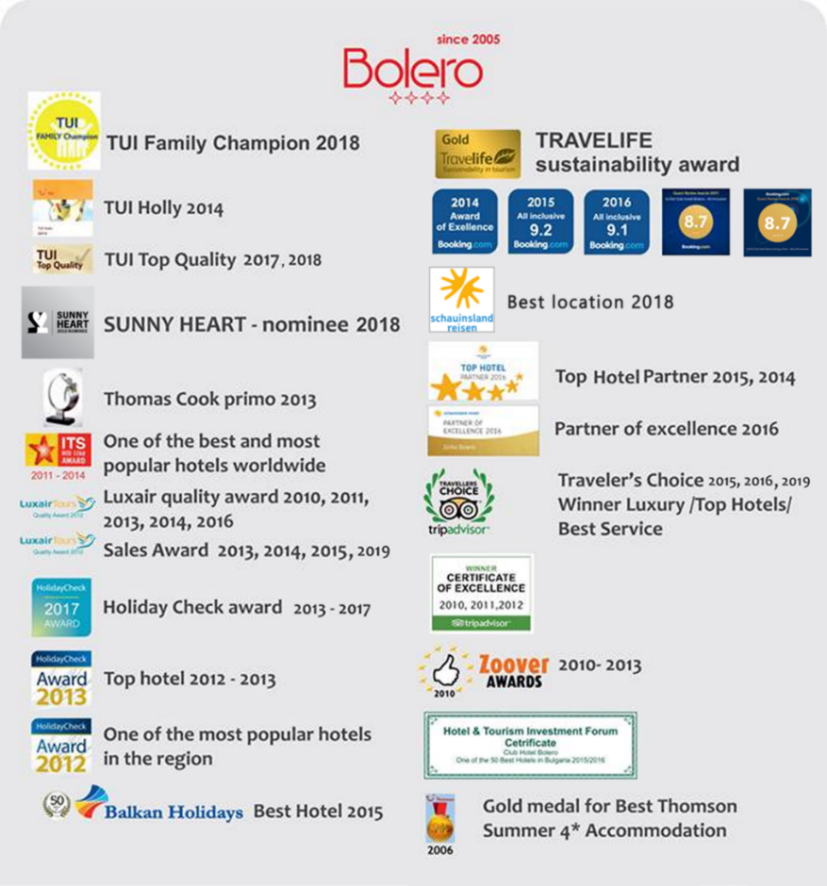
- Food and beverages cannot be taken out of the restaurants due to Public and HACCP regulations

CONTACTS

Tel.: +359 52 333 666 (Hotel Reception)
WEBSITE
www.grifidhotels.com
PHOTOS
https://grifidbolero.pixieset.com/grifidhotelbolero/
AWARDS

